Photo #1 is inappropriate because the airline employee seems to have slept on the back deck. This is not an appropriate photo as it would pose a negative image to the company.
Photo #2 is inappropriate because it is vulgar and abusive to show the middle finger to the employees.
Photo #3 is appropriate because employees seem to be relaxing in the workplace.
Photo #4 is inappropriate because the employee does not seem to have taken the Covid-19 measures and protocol aimed at ensuring that the employee does not engage in any transmission of a virus.
Photo #5 is appropriate because the employees seemed to have undertaken control of the covid measures.

Photo #1 Photo #2 Photo #3
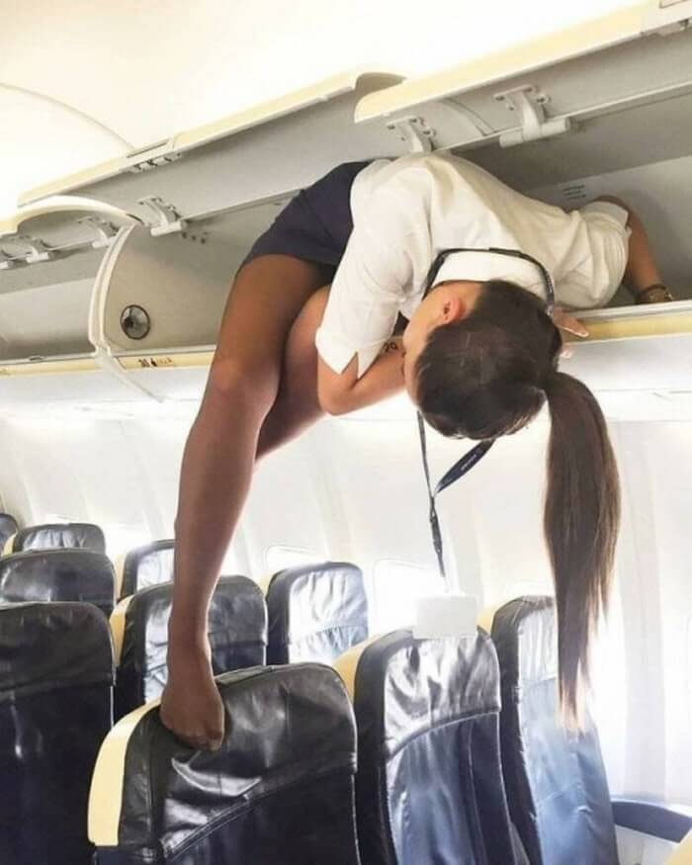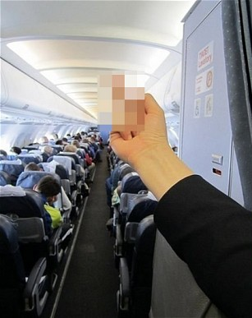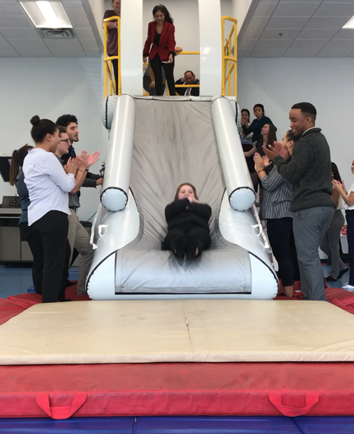
Answer:
APPROPRIATE
Answer:
INAPPROPRIATE
Answer: INAPPROPRIATE

Photo #4 Photo #5
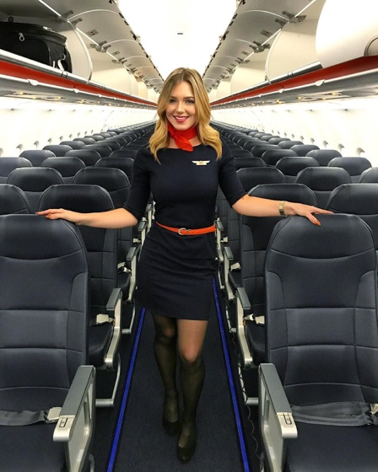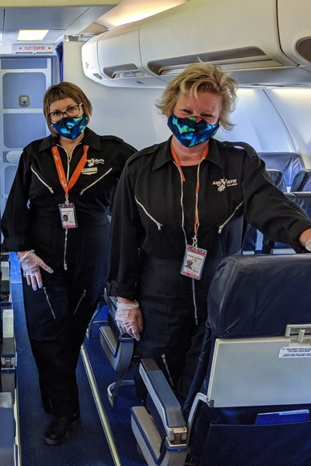

Answer:
APPROPRIATE
Answer: INAPPROPRIATE

